We can use a 500mAh lithium polymer battery to power our product. The 500mAh lithium polymer battery connects directly to the JST connector on the Adafruit Feather ESP32. It is small and easy to carry around

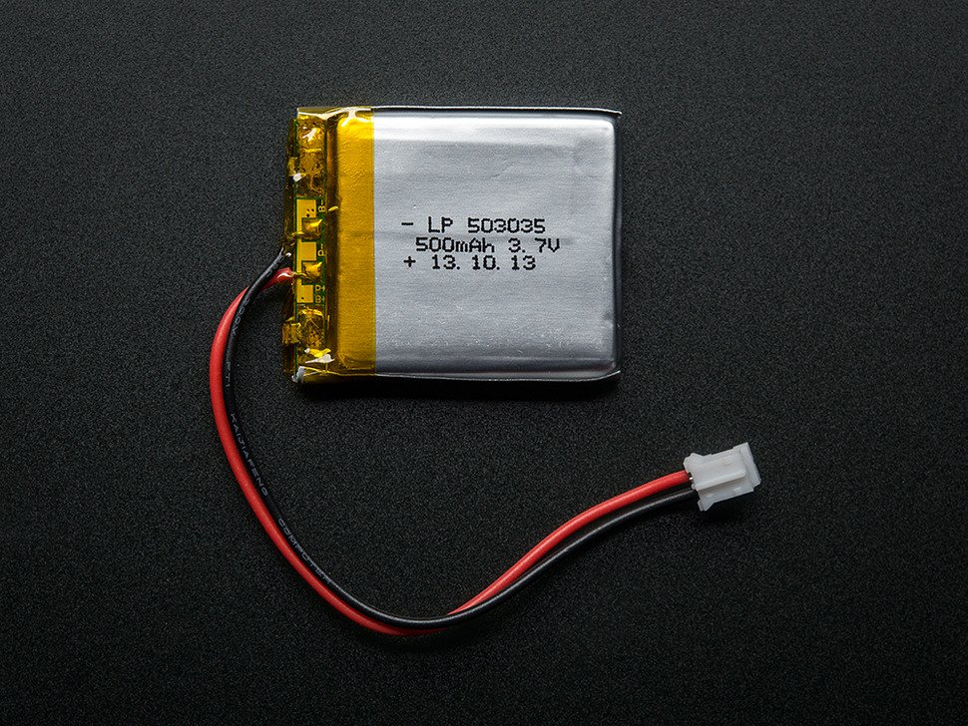

Link: <https://www.adafruit.com/product/1578>

We could also use a switcher to turn on and off the power source.

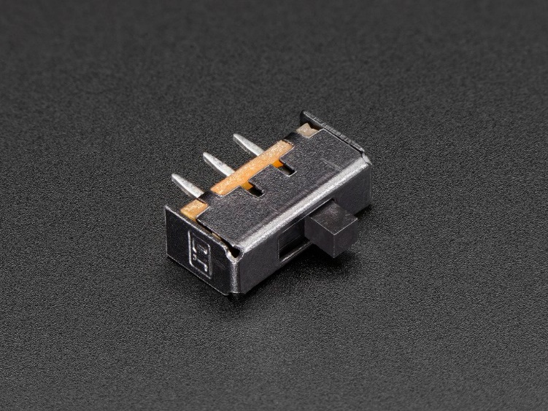

Link: <https://www.adafruit.com/product/805>

The circuit diagram could be as:

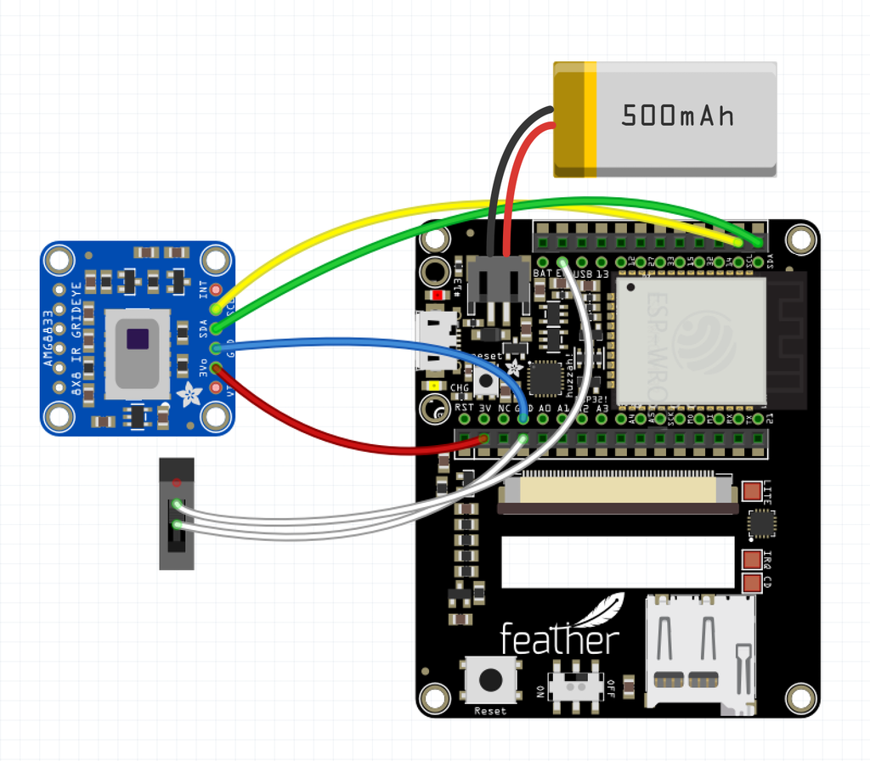

References for this document is from: <https://learn.adafruit.com/thermal-camera-with-display/tft-featherwing?view=all>.

We can also refer how to make a case in this project:

